09 Childcare practice procedures
09.1a Prospectus
Dear Parent/Carer,
Welcome to The Sombornes Pre-school, we look forward to getting to know you and your child. Please find enclosed a copy of our Prospectus, which contains useful information and will hopefully answer any questions you may have.
It may also be useful to familiarise yourself with our website which can be found at www.thesombornespreschool.co.uk. Here you can find our latest messages, newsletters and all of our policies and procedures. Please could you ensure that you have read our Safeguarding policy as a priority, before looking at our other policies. We also have a closed Facebook page, where we share with you, photos of the children, as well as any information we have.
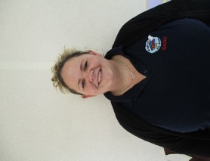
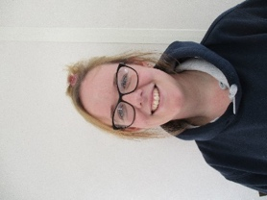
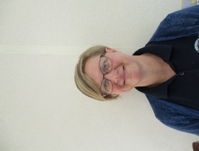
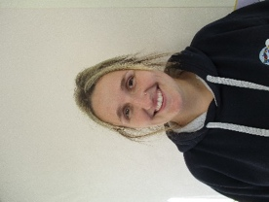
Meet Our Team:
Becky
Supervisor
Katie
Assistant Supervisor
Kelly
Practitioner
Siobhán
Practitioner

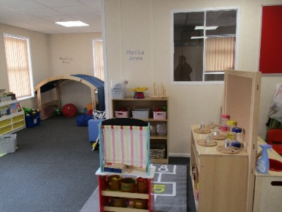
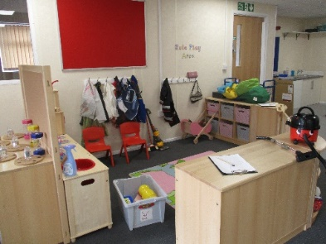
Our Pre School:

The Annex, Village Hall, Romsey Road, King’s Somborne,
Stockbridge, Hampshire, SO20 6PP
Tel: 07530893773
www.thesombornespreschool.co.uk
email: manager@thesombornespreschool.co.uk
Prospectus
Registered Charity No: 1031324
EYE Registered No: 517579
Ofsted No: 109890
PLA Member

Welcome to The Sombornes Pre-school! We are an independent, Ofsted registered pre-school offering education through play in a friendly informal setting for children aged 2 years to school age. We currently offer sessions from 08:45 am to 3.00pm Monday, Tuesday, Wednesday and Thursday and Friday 08:45am-12:45pm.

We know how important your child is and aim to deliver the highest quality of care and education to help them to achieve their best.

This prospectus aims to provide you with an introduction to The Sombornes Pre-school, our routines, our approach to supporting your child’s learning and development and how we aim to work together with you to best meet your child’s individual needs.

Our setting aims to:

- Provide high quality care and education for children below statutory school age
- Work in partnership with parents to help children to learn and develop
- Add to the life and well-being of the local community; and
- Offer children and their parents a service that promotes equality and values diversity.


Parents:

You are regarded as members of our setting who have full participatory rights. These include a right to be:
- Valued and respected
- Kept informed
- Consulted
- Involved
- Included at all levels.

As a voluntary managed setting, we also depend on the goodwill of parents and their involvement to keep going. Membership of the setting carries expectations on you for your support and commitment.

Children's development and learning:

We aim to ensure that each child:
- Is in a safe and stimulating environment
- Is given generous care and attention
- Has the chance to join in with other children and adults to live, play, work and learn together
- Is helped to take forward her/his learning and development by being helped to build on what she/he already knows and can do
- Has their own key person who makes sure each child makes good progress
- Is in a setting that sees parents as partners in helping each child to learn and develop; and
- Is in a setting in which parents help to shape the service it offers.
- Has a personal key person who makes sure each child makes satisfying progress
- Is in a setting that sees parents as partners in helping each child to learn and develop
- Is in a setting in which parents help to shape the service it offers

The Early Years Foundation Stage (EYFS):

Provision for the development and learning of children from birth to 5 years is guided by the Early Years Foundation Stage. Our provision reflects the four overarching principles of the Statutory Framework for the Early Years Foundation Stage:

A Unique Child
Every child is a unique child who is constantly learning and can be resilient, capable, confident and self-assured.

Positive Relationships
Children learn to be strong and independent through positive relationships.

Enabling Environments
Children learn and develop well in enabling environments with teaching and support from adults, who respond to their individual interests and needs and help them to build their learning over time. Children benefit from a strong partnership between practitioners, parents and/or carers.

Learning and Development
Children develop and learn in different ways and at different rates. The framework covers the education and care of all children in early years provision including children with special educational needs and disabilities. (SEND)

How we provide for development and learning
Children start to learn about the world around them from the moment they are born. The care and education offered by our setting helps children to continue to do this by providing all of the children with interesting activities that are appropriate for their age and stage of development.

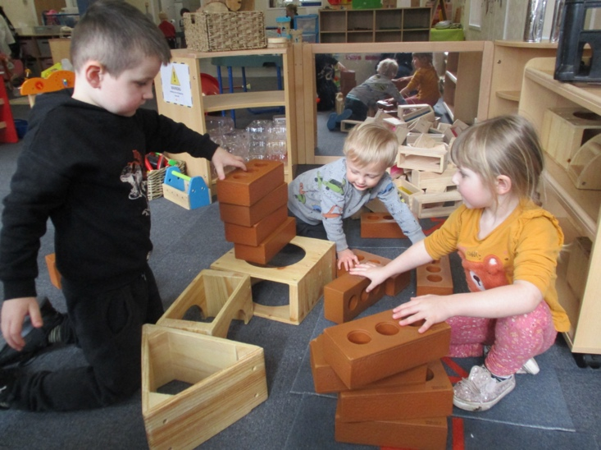
The Areas of Development and Learning comprise:

Prime Areas
- Personal, social and emotional development
- Physical development
- Communication and language

Specific Areas
- Literacy
- Mathematics
- Understanding the world
- Expressive arts and design

For each area, the level of progress that children are expected to have attained by the end of the Early Years Foundation Stage is defined by the Early Learning Goals. These goals state what it is expected that children will know, and be able to do, by the end of the reception year of their education.

The Early Years Outcomes
We refer to non-statutory curriculum guidance to support our professional judgment as we assess each child’s progress and level of development as they progress towards the Early Learning Goals. We have regard to these when we assess children and plan for their learning by creating a curriculum that is ambitious and meets every child’s needs. Our educational programmes support children to develop the knowledge, skills and understanding they need for

Personal, social and emotional development
- Sense of self
- Managing self
- Understanding feelings

Physical development
- Moving and handling
- Health and self-care

Communication and language
- Listening and attention
- Understanding
- Speaking

Literacy
- Reading
- Writing
Mathematics
- Mathematics

Understanding the world
- People and communities
- The world
- Technology

Expressive arts and design
- Creating with materials
- Being imaginative and expressive

Our approach to learning and development and assessment:

Learning through play

Being active and playing supports young children’s learning and development through doing and talking. This is how children learn to think about and understand the world around them.

We use the EYFS statutory guidance on education programmes to plan and provide opportunities which will help children to make progress in all areas of learning. This programme is made up of a mixture of activities that children plan and organise for themselves, and activities planned and led by educators.
Characteristics of effective learning (COEL)

We understand that all children engage with other people and their environment through the characteristics of effective learning that are described in the Early Years Foundation Stage as:
- Playing and exploring - engagement
- Active learning - motivation
- Creating and thinking critically - thinking.

We aim to provide for the characteristics of effective learning by observing how a child engages with learning and being clear about what we can do and provide to support each child to remain an effective and motivated learner.

Key person and your child

Our setting uses a key person approach. This means that each member of staff has a group of children for whom she/he is particularly responsible. Your child's key person will be the person who works with you to make sure that the childcare that we provide is right for your child's particular needs and interests. When your child first starts at the setting, she/he will help your child to settle and throughout your child's time at the setting, she/he will help your child to benefit from the setting's activities.

Assessment

We assess how young children are learning and developing by observing them. We use information that we gain from observations, as well as from photographs or videos of the children, to document their progress and where this may be leading them. We believe that parents know their children best, and we will ask you to contribute to assessment by sharing information about what your child likes to do at home and how you, as parents/carers are supporting development.

We make periodic assessment summaries of children’s achievement based on our on-going development records. These form part of children’s Learning Journals. We undertake these assessment summaries at regular intervals, as well as times of transition, such as when a child moves into a different setting or when they go on to school. Whenever we do a Progress Report, we always arrange a meeting with you to discuss your child’s development and the next steps in their learning.

The progress check at age two

The Early Years Foundation Stage requires that we supply parents and carers with a short, written summary of their child’s development in the three prime areas of learning and development - personal, social and emotional development; physical development; and communication and language - when a child is aged between 24 - 36 months. Your child’s key person is responsible for completing the check using information from on-going observational assessments carried out as part of our everyday practice, taking account of the views and contributions of parents and other professionals.

Learning Journals

We keep a record of achievement for each child using Learning Journal, which you are able to access anytime. This helps us to celebrate together her/his achievements and to work together to provide what your child needs for her/his well-being and to make progress.

Your child's key person will work in partnership with you to keep this record. To do this you and she/he will collect information about your child's needs, activities, interests and achievements and add observations, photos and comments to their Learning Journal. This is very much a two-way process and the information gathered will enable the key person to identify your child's stage of development. Together, we will then decide on how to help your child to move on to the next stage.

Working together for your children

We always maintain at least the ratio of adults to children in the setting that is set by the statutory safeguarding and welfare requirements and in nearly all cases above this requirement. We sometimes have volunteer parent helpers, to complement these ratios.

These high adult child ratios help us to:
- Give plenty of time and attention to each child
- Talk with the children about their interests and activities
- Help children to experience and benefit from the activities we provide
- Allow the children to explore and be adventurous in safety.

How parents take part in the setting
Our setting recognises parents as the first and most important educators of their children. All of our staff see themselves as partners with parents in providing care and education for their children.

There are many ways in which parents take part in making our setting a welcoming and stimulating place for children and parents, such as:

- Exchanging knowledge about their children's needs, activities, interests and progress with our staff
- Contributing to the progress check at age two
- Helping at sessions of the setting
- Sharing their own special interests with the children
- Helping to provide and look after the equipment and materials used in the children's play activities
- Being part of the management of the setting where appropriate
- Taking part in and contributing to fundraising events
- Joining in community activities, in which the setting takes part
- Building friendships with other parents in the setting.

Day to Day Check List

Make sure that you arrive for a prompt start, this is important as it can be unsettling for your child if you are late. If your start time is 08:45 then you will arrive through the pre-school entrance. Please wait for a member of staff to open the door.

Please make sure that you sign your child in the register each day and ensure that pre-school staff know if he/she is going to be collected by someone else.

We do ask that your child is dressed in suitable clothing and footwear at all times. It is advisable not to send them in “best clothes” as while we provide aprons for messy play children have an uncanny knack of getting their clothes messy anyway.

The children are able to play outside whatever the weather, so it is important that in warm, sunny weather you provide a sun hat and apply sunscreen before coming in and make sure they have coats, hats, gloves and wellies in the winter. We do our best at pre-school to encourage children’s independence and self-help skills in preparation for school, so we ask that when at pre-school your child wears the following:
- Layered tops in cold weather, covered shoulders in hot weather
- No fiddly buttons or ties
- Leggings or trousers that are easy for the child to pull up and down (absolutely essential when toilet training and useful to avoid little accidents later on!) Long skirts and dresses can make it difficult to toilet independently and are certainly a hindrance when playing outside as they get caught in bike wheels and are tricky to climb in. The same goes for tight trousers!
- Easy to manage shoes e.g., Velcro fastenings. No shoes or boots with laces or other tricky fastenings as these do not aid children in becoming independent. Ensure that all items of clothing especially pre-school uniform, coats, shoes and wellies are clearly marked with your child’s name.
- When you collect your child promptly (at the Pre-school entrance) we ask that you wait at the door for a member of staff to open it. You may then come up to the door to collect your child and sign them out. For health & safety and insurance purposes we must insist that you do not allow siblings and ‘signed out’ pre-school children to play on the pre-school equipment.
- Children can become very distressed if you are late so please do your best to arrive on time to collect them. If for any reason you will not be able to collect your child, please ring to let us know who will be collecting them. We will not allow a child to leave with anyone without your written or verbal permission. If you are unavoidably delayed it is essential that you ring and let us know. Repeated lateness will incur a late fee of £1.00 per minute.
- Assist with fundraising activities and attend committee meetings whenever possible.
- Please notify the pre-school of any planned holidays.
- Please notify us by text, a call or email if your child will be absent for any other reason e.g., illness. If we do not hear from you, we will contact you to check everything is o.k.
- Notify the staff of any contagious illness, such as chicken pox and/or head lice.
- Please do not bring your child to the pre-school if they are unwell (fever or sickness or diarrhoea). They can return after they have been clear of illness for 48 hours.
- Provide your child with a healthy snack each day (fresh or dried fruit or vegetable) in a clearly labelled container.

The setting's timetable and routines

Our setting believes that care and education are equally important in the experience which we offer children. The routines and activities that make up the day in our setting are provided in ways that:
- Help each child to feel that she/he is a valued member of the setting
- Ensure the safety of each child
- Help children to gain from the social experience of being part of a group
- Provide children with opportunities to learn and help them to value learning.

Our Day

We organise our sessions so that the children can choose from, and work at, a range of activities and, in doing so, build up their ability to select and work through a task to its completion. The children are also helped and encouraged to take part in adult-led small and large group activities, which introduce them to new experiences and help them to gain new skills, as well as helping them to learn to work with others. Outdoor activities contribute to children’s health, their physical development and their knowledge of the world around them. The children have the opportunity, and are encouraged, to take part in outdoor child-chosen and adult-led activities, as well as those provided in the indoors.

Snack

In line with our healthy eating policy, we ask that you provide your child with a healthy snack of fresh or dried fruit or vegetable each day. This should be prepared and labelled with their name and placed in the box next to the daily register. Water and milk, provided by us, is available to drink throughout the day. Children are encouraged to pour their own drinks.

Lunch time

Our lunch time is between 12 midday and 1pm. Those children staying for lunch can bring a healthy packed lunch.

WE ARE STRICTLY NUT FREE AND ASK THAT YOU ARE VIGILANT IN MONITORING THE CONTENTS OF PACKED LUNCHES.

Sometimes we have a cookery activity or food tasting session, which the children are encouraged to join in, please let us know if your child is allergic to or should avoid certain food items.

Should My Child Be Bringing Something Home Each Day?

Whilst it can be reassuring for you to see what your child has been doing, expecting them to bring something home after each session is not very realistic. It can also create a lot of pressure. It is important to remember that creativity is not just about ‘producing’ things. Children who have simply enjoyed playing with play dough, Lego and ribbons will have been just as creative as a child who has been drawing. Creative development also includes imaginative play such as dressing up, role play and playing with play people or music making.

Library Books

Your child will be provided with their own book bag and will be encouraged to choose a library book to read with you at home. They can change this book each time they come in if they wish, but we do not change these books if the child tells us they haven’t read it yet as it is quite time consuming and there is little point in us changing book after book just to take it back and forth without reading it!
Staff Training

As well as holding relevant qualifications in early years care and education the pre-school staff regularly take part in further training to help them to keep up to date and develop practises which enable all children within our care to flourish.
The pre-school also keeps itself up to date with best practice in Early Years Care and Education through the Pre-School Learning Alliance's magazine Under Five and publications produced by the Pre-School Learning Alliance.

Policies & Procedures

In order to comply with National Standards, the pre-school has adopted policies and procedures which help us to make sure that the service we provide is of high quality and that being a member of the pre-school is an enjoyable and beneficial experience for each child and his/her parents.

All policies & procedures are available to view on our website www.thesombornespreschool.co.uk or there is a hard copies available at pre-school, just ask a member of staff if you would like to read them.

Safeguarding children

Every child has the right to be protected, and it is everyone’s responsibility to protect children.

Our setting has a duty under the law to help safeguard children against suspected or actual ‘significant harm’. Our employment practices ensure children are protected against the likelihood of abuse in our setting and we have a procedure for managing complaints or allegations against a member of staff.

Our way of working with children and their parents ensures that we are aware of any problems that may emerge and can offer support, including referral to appropriate agencies when necessary, to help families in difficulty.

Please make us aware if your child has had an accident and has a bruise or mark. We will ask you to fill out a pre-existing injury form please don’t be alarmed, this is good practice and is there to protect both yourself and our team.

Mobile phones

We ask all parents to keep mobile phones in pockets, or bags and not to take calls while in the setting. No pictures should be taken in the setting unless the manager has granted permission.

Special needs

To make sure our provision meets the needs of each individual child, we take account of any special needs a child may have. We work to the requirements of the Special Educational Needs and Disability Code of Practice: 0 to 25 years (2015).
Our special educational needs coordinator (SENCo) is Rebecca Lane and Katie Grant

The Committee

The Committee of The Sombornes Pre-school is voluntary and made up mainly of parents, whose children attend the pre-school. It consists of at least five trustees including an elected Chairperson, Treasurer and Fundraisers. These people are entrusted with the overall responsibility for ensuring that the group runs successfully.

The Annual General Meeting is held every year, when the Committee for the next school year is elected, all parents are invited to attend.
The Annual General Meeting is a forum for looking back over the previous year's activities and shaping the coming year's plan.

Please feel free to talk with any of the Committee Members or Staff if you have any questions at all regarding The Sombornes Pre-school.

The committee is responsible for:

- Managing the Pre-school's finances
- Employing and managing the staff
- Making sure that the Pre-school has - and works to - policies which help it to provide a high-quality service
- Making sure that the Pre-school works in partnership with the children's parents.

Fundraising

The fees you pay to pre-school are used primarily to cover staff costs, rent and insurance. We therefore rely on parental generosity to support our various fundraising events during the year – these funds enable us to provide numerous, high-quality resources, activities and learning experiences as well as replacing and purchasing new equipment.

Attendance

Although Early Years Education is not compulsory, we would anticipate that your child will attend in accordance with the agreed pattern.
We endeavour to be as flexible as possible and offer you the opportunity to review your child’s hours of attendance each term.
Once you have booked and agreed on your child’s hours for the coming term the hours may not be decreased until the following term (i.e. should you decide to reduce the hours your child attends the booked hours are still payable for that term).
Hours may be increased on a permanent basis on request if we have the space to accommodate your child.

Notice

A minimum of half a term written notice is required if you withdraw your child from the pre-school, otherwise half a terms fees become payable. This does not apply to funded hours.

Fees
Fees are payable each half term in advance, an invoice will be sent to you but you can make other arrangements if you wish, by speaking to Rebecca Lane (manager) or the Treasurer. Fees continue to be payable if a child is absent due to illness or holidays. In cases of prolonged absence, parents should consult the manager about the fee payment.

Fees are currently £7.75per hour.

For your child to keep her/his place at our setting, you must pay the fees. We are in receipt of nursery education funding for two, three and four year olds; where funding is not received, then fees apply.

Please note that your child will be required to attend a minimum of two 3-hour sessions (or 1 whole day), per week.

Funding

Universal Offer:
The Government provides 15 hours per week funded Early Years Education for 38 weeks of the year to all children from the term after their third birthday. The pre-school will issue the relevant forms for claiming the universal free 15 hours when necessary.

2-Year-Old Offer:
Your 2-year-old can get 15 hours free early education and childcare per week from the term after their 2nd birthday if you live in England and get one of the following benefits:
- Income Support
- Income-based Jobseeker’s Allowance (JSA)
- Income-related Employment and Support Allowance (ESA)
- Universal Credit
- Tax credits and you have an annual income of under £16,190 before tax
- The guaranteed element of State Pension Credit
- Support through part 6 of the Immigration and Asylum Act
- The Working Tax Credit 4-week run on (the payment you get when you stop qualifying for Working Tax Credit)

A child can also get free early education and childcare if any of the following apply:
- They’re looked after by a local council
- They have a current statement of special education needs (SEN) or an education, health and care (EHC) plan
- They get Disability Living Allowance
- They’ve left care under a special guardianship order, child arrangements order or adoption order.

30 Hours Offer:

You may be able to receive up to 30 hours free childcare per week of each child aged 9 months old – 570 hours a year on top of the ‘universal’ entitlement of 570 hours (15 hours per week).

Are you eligible?
One or two parent households need to be working and earning at least the equivalent each week of 16 hours at the National Minimum or Living Wage (though less than £100,000 each per annum).

‘Working’ includes those parents who are self-employed, on zero contract hours or on maternity, paternity or adoption leave, and meet the income criteria.

In two parent households one parent can be disabled, have caring responsibilities or being assessed for work to be eligible.

Your child needs to be aged 3 or 4 to access 30 hours free childcare and will become eligible from the term following their 3rd birthday.

To find out more and apply:
Visit the Government ‘Childcare Choices’ service at: https://www.childcarechoices.gov.uk/

Other types of support are available. Use the Childcare Calculator to find out what is best for your family at: https://www.gov.uk/childcarecalculator

Need help with the online application or further information?
Contact the Childcare Choices helpline: 0300 123 4097 (Open 7 days a week).

Information/newsletters/website

There is a notice board in the reception area of the pre-school which details information on upcoming events and activities, it is therefore important to read this, whenever you drop off/collect your child. We also produce half termly newsletters giving details of forthcoming events, activities and fundraising activities; these are made available by email and through our website (hard copies available on request). Please make sure you read these as they can contain important information. Our website, www.thesombornespreschool.co.uk is also regularly updated and contains lots of information about our pre-school. We always welcome your suggestions. This information can be made available on audio tape or in Braille if required.

Starting at our setting

We want your child to feel happy and safe with us. To make sure that this is the case, our staff will work with you to decide on how to help your child to settle into our pre-school. Our policy on the Role of the Key Person and Settling in is available on our website www.thesombornespreschool.co.uk.

We hope that you and your child enjoy being members of our setting and that you both find taking part in our activities interesting and stimulating. Our staff are always ready and willing to talk with you about your ideas, views or questions.

It’s not “just play”

Play is an essential part of early learning.

It is the lifeblood of the learning process.

As children play they are developing the cognitive, socio-emotional and physical
skills they will need to take them into a successful adulthood.

They are developing their curiosity, problem solving, intentionality,
flexibility and verbal & non-verbal skills.

Socio-emotionally they are developing their emotional intelligence – learning
confidence, cooperation, negotiation, sharing, empathy
and how to communicate appropriately.

Physically their fine motor and gross motor skills are being practised and developed.

It’s not “just play” they are skills for life!

(MHC Early Childhood Solutions)

